Final Report

By Cody Kou

**Abstract:**

In general, comparing to normal operation, the average safety scores improved and we could confidently conclude that the improvement is due to the equipment's protection - wearing the sensor and turning on the vibrational alerts.

Among the 3 haptic options, user could benefit more when the vibrational alert is set to “2 bends in 5 minute window over 65 degrees”.

**Processing and findings:**

After handling the missing values and outliers, the dataset was split by the “Baseline or Intervention” and “3 bends in 8 minute window over 65 degrees, 2 bends in 5 minute window over 65 degrees, or 2 bends in 10 minute window over 65 degrees.

Data distribution check performed once on 1 of the haptic group as shown as below:

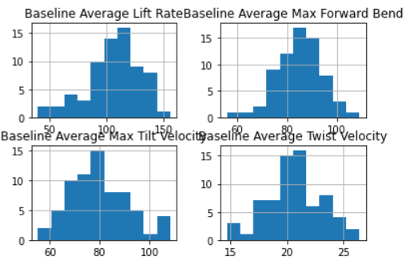

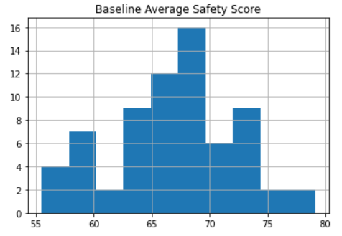

Based on the plot, the dataset distribution could be assumed to be normal distribution.

Then the weighted average figures are calculated based on file counts, and the t-tests are performed, the results are summarized under different haptic options, shown as below:

1. Result for “3 bends in 8 minute window over 65 degrees”

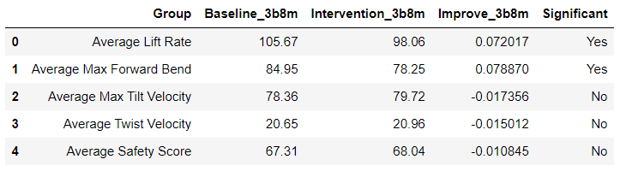

1. Result for “2 bends in 5 minute window over 65 degrees”

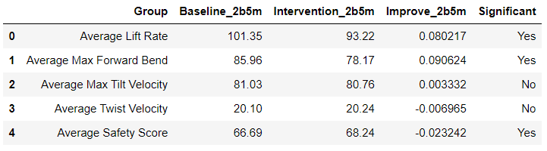

1. Result for “2 bends in 10 minute window over 65 degrees”

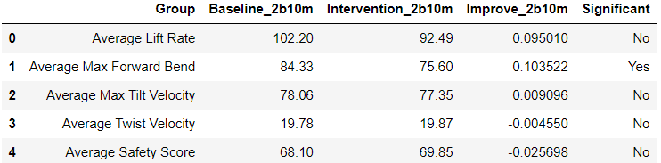

**Summary insights and recommendations:**

* Assumption 1: Average safety score is considered to be the most valuable metric for evaluating the overall performance
* Assumption 2: The provided dataset is sufficient and could be considered as normal distributed.
* Insight 1: In general, comparing to normal operation, the average safety scores improved and we could confidently conclude that the improvement is due to the equipment's protection - wearing the sensor and turning on the vibrational alerts.
* Insight 2: Users could reduce the average number of bends per hour and the average max forward bend in degrees due to the vibrational alerts thus lowering the risk of being injured.
* Insight 3: No evidence shows that there are significant changes or improvements for the speeds of tilt and twist.
* Insight 4: When the vibrational alert is set to 2 bends in 5 minute window over 65 degrees, the equipment performed the best. The result shows significant improvement for lowering the average number of bends per hour, the average max forward bend in degrees, and most importantly, increasing the average safety score by 2.32%.
* **Recommendations**: Among the 3 haptic options, user could benefit more when the vibrational alert is set to 2 bends in 5 minute window over 65 degrees.

**Future Consideration:**

* Different locations(warehouses) and job functions plus associated information should be taken into consideration.
* Different variance/std by different file counts should be taken into consideration for best t-test result.
* Based on the results of 3 haptic options, it might be the case that the more frequently the alert is triggered, the better result in protection may achieved. So more haptic options could be tested for best result.